Introduction to SonarQube and Its Features

What is SonarQube?
- SonarQube is a powerful tool for improving code quality in software development.
- SonarQube is an open-source platform developed by SonarSource for continuously inspecting code quality.
- It supports 30 major programming languages with various plugins.
- It acts as a code inspector, analyzing code to identify errors, bugs, issues, mistakes, duplication, and security vulnerabilities.
- SonarQube is developed using the Java programming language.
- Think of it as a digital assistant that helps programmers create reliable and secure software.
- SonarQube provides integration with different build tools like Maven, Ant, Gradle, MSBuild, and continuous integration (Azure DevOps, Atlassian Bamboo, Jenkins, Hudson, etc.).
Features of sonarqube
- Multi-Language Support: It Offers analysis for more than 30 programming languages.
Press enter or click to view image in full size
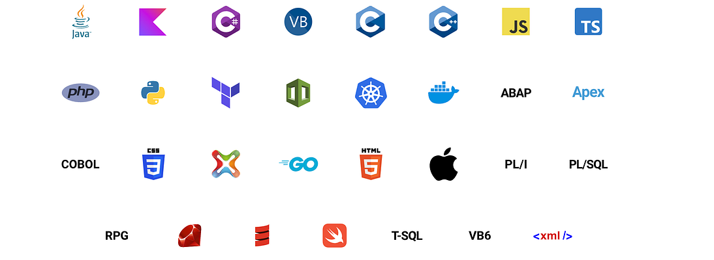
2. It can detect various types of Tricky issues in the code.
Bugs: A bug is a tiny mistake or problem in the code that can cause the software to behave unexpectedly or even crash.
Imagine you’re building a calculator app to add numbers. You write code for addition like this:
Press enter or click to view image in full size
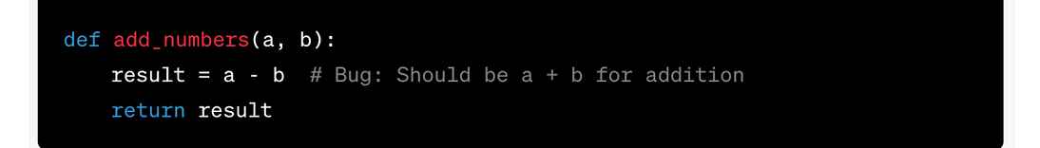
Here’s a bug: Instead of adding a and b, you accidentally subtract them. So, when users try to add 5 and 3, your app gives them 2 (5 + 3) instead of the correct result, which should be 8 (5 + 3).
SonarQube would spot this bug and tell you that the addition isn’t working as expected. It would suggest changing a - b to a + b to fix the bug and make sure your calculator app adds numbers correctly.
Vulnerability:
- A vulnerability refers to a weakness or flaw in the code.
- A security-related issue that represents a backdoor for attackers
Press enter or click to view image in full size

For example, imagine you’re building a login system for a website. If your code doesn’t properly validate user input and leaves room for SQL injection, attackers could manipulate the input to gain unauthorized access to sensitive data or even control the system.
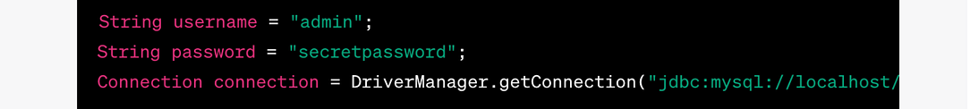
Another example of a vulnerability is hardcoding sensitive-value usernames, passwords, or tokens.
Code smell:
- Code smells are characteristics of code that indicate the possibility of a problem caused by code in the future.
- A maintainability-related issue in the code.
- A typical example of a code smell is duplicated code, a long method, or a long class.
For example, Suppose you have a Python function that calculates the area of different shapes, and it has become quite lengthy:
Press enter or click to view image in full size
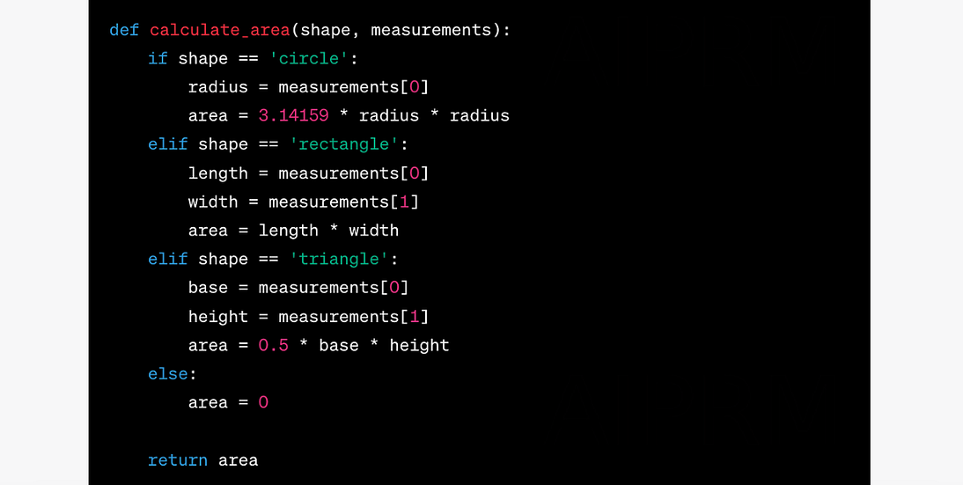
In this example, thecalculate_area function handles different shapes, but the logic is combined into a single long method. This can make the code harder to read and maintain over time.
Remember me for faster sign in
To address this code smell, you could break down the function into smaller, more focused functions:
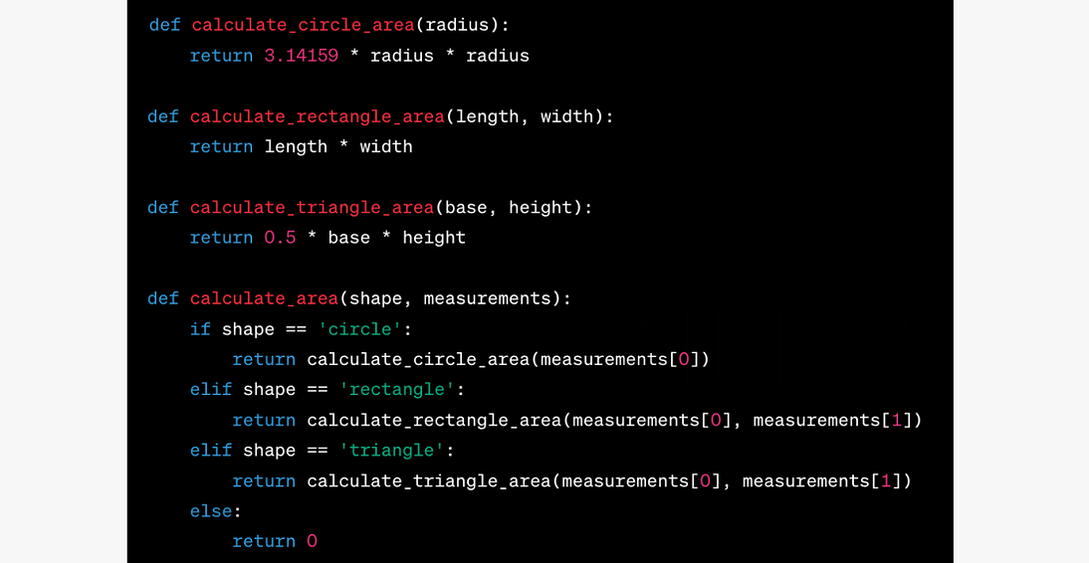
By breaking down the code into smaller functions, you improve readability and maintainability.
Code duplications: Code duplication in SonarQube means having the same or very similar pieces of code repeated in different parts of your program. It’s like copying and pasting the same instructions in multiple places.
For example, Suppose you’re working on a Python program that converts temperatures from Celsius to Fahrenheit and vice versa. Here’s an example of code duplication:
Press enter or click to view image in full size
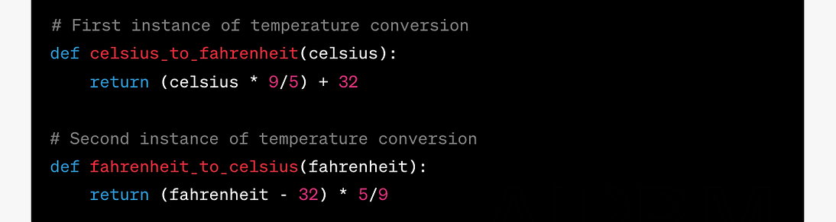
To address this code duplication, you can create a single function that handles both conversions:
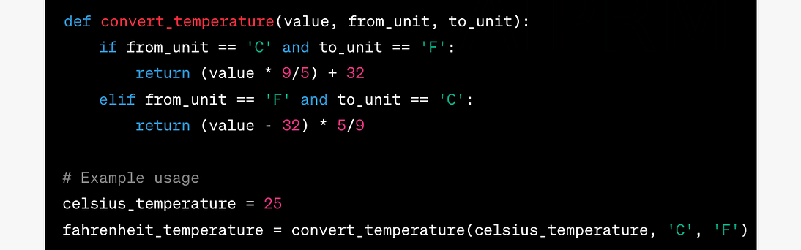
SonarQube helps you spot and fix instances of code duplication like this, improving your code’s quality and readability.
Security hotspots are security-sensitive pieces of code that need to be manually reviewed. Upon review, you’ll either find that there is no threat or that there is vulnerable code that needs to be fixed.
Code Coverage: It is a measure of how much of your code is tested by your automated tests. It shows the percentage of your code that gets exercised by your tests.
For example, you have a simple program in Java that calculates the square of a number.
Press enter or click to view image in full size
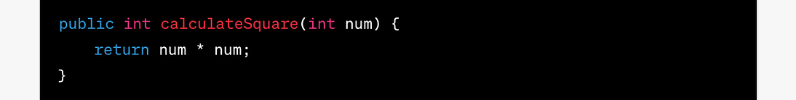
You create a test suite with a test for the calculateSquare function:
Press enter or click to view image in full size
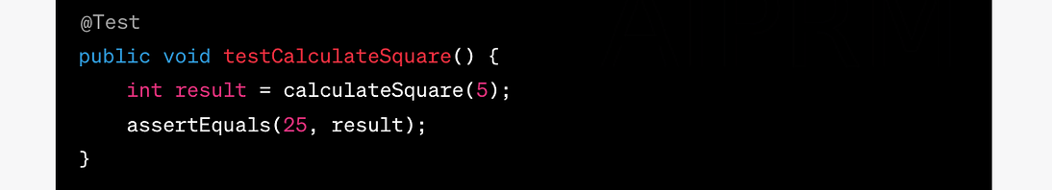
When you run your tests and analyze them in SonarQube, you might see that the code coverage for the calculateSquare function is 100%. This means that all lines of code in that function were executed during the test.
3. Integration with CI/CD:
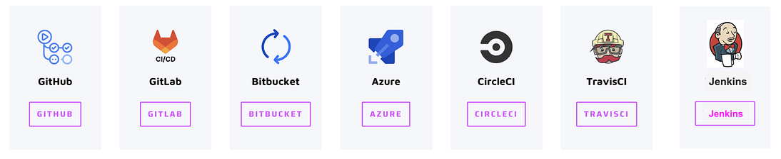
Integrating SonarQube with your Continuous Integration and Continuous Deployment (CI/CD) pipeline enhances code quality and security checks throughout your software development lifecycle.
4. Sonarlint IDE integration:
Press enter or click to view image in full size
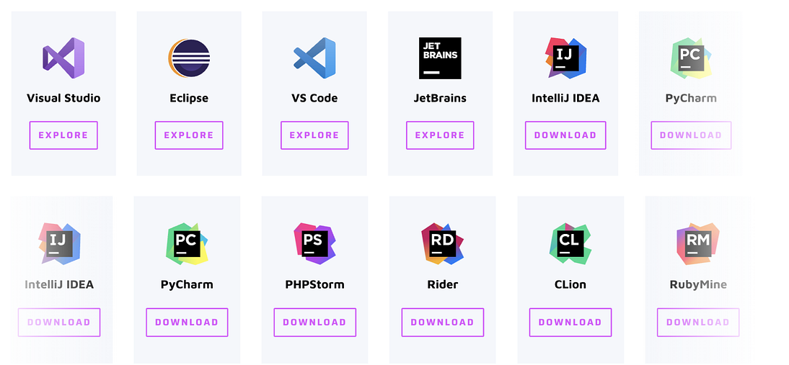
SonarLint is a powerful tool that enhances code quality by providing real-time code analysis and feedback within your Integrated Development Environment (IDE). It helps you identify and address code issues early in the development process. SonarLint can be integrated with various IDEs to support different programming languages and frameworks.
5. Plugin Ecosystem:
Press enter or click to view image in full size

- Plugins in SonarQube are extensions that enhance the platform’s functionality by adding additional rules, integrations, and features
- Think of plugins in SonarQube as adding extra tools to your toolbox.
- Plugins in SonarQube are like special add-ons that give it extra powers.
Imagine you’re building a website using CSS, but it might not automatically understand all the details of the code. This is where a plugin like “SonarCSS” will make SonarQube smarter and help detect the different issues.
6. Sonarqube Rules:
- A coding standard or practice that should be followed.
- Not complying with coding rules can lead to bugs, vulnerabilities, security hotspots, and code smells.

🧪 LAB: SonarQube with .NET (Step-by-Step)
🎯 Objective
- Set up SonarQube locally
- Create a .NET project
- Analyze code quality using SonarQube
- View bugs, vulnerabilities, and code smells

🧰 Prerequisites
Make sure you have:
- .NET SDK (6 or later)
- Java (required for SonarQube)
- SonarScanner for .NET
- SonarQube (Community Edition)

🏗️ Step 1: Download & Start SonarQube
- Download SonarQube (Community Edition)
- Extract the zip
- Navigate to:
sonarqube/bin/windows-x86-64
- Run:
StartSonar.bat
👉 Open browser:
http://localhost:9000
🔐 Default Login
- Username: admin
- Password: admin

🔑 Step 2: Generate Token
- Go to My Account → Security
- Generate a token (e.g., dotnet-token)
- Copy and save it

⚙️ Step 3: Install SonarScanner for .NET
Run:
dotnet tool install --global dotnet-sonarscanner
Verify:
dotnet sonarscanner --version

🧱 Step 4: Create Sample .NET Project
dotnet new webapi -n SonarDemo
cd SonarDemo
Run project:
dotnet run

🧪 Step 5: Add Sample Bad Code (for testing)
Modify any controller:
public int Divide(int a, int b)
{
return a / b; // No validation (issue)
}
public void EmptyMethod()
{
// Code smell
}

🚀 Step 6: Run SonarQube Analysis
1️⃣ Begin Analysis
dotnet sonarscanner begin \
/k:"SonarDemoProject" \
/d:sonar.host.url="http://localhost:9000" \
/d:sonar.login="YOUR_TOKEN"

2️⃣ Build Project
dotnet build

3️⃣ End Analysis
dotnet sonarscanner end \
/d:sonar.login="YOUR_TOKEN"

📊 Step 7: View Results
Open:
http://localhost:9000
👉 You will see:
- Bugs 🐞
- Vulnerabilities 🔐
- Code Smells 💡
- Coverage (if configured)

🔍 What SonarQube Detects
🐞 Bug Example
return a / b; // divide by zero risk
🔐 Security Issue
- Hardcoded passwords
- SQL Injection risks
💡 Code Smell
- Unused methods
- Long methods
- Poor naming

🧪 Step 8: Fix Issues and Re-run
Fix:
public int Divide(int a, int b)
{
if (b == 0)
throw new ArgumentException("b cannot be zero");
return a / b;
}
Re-run analysis → see improved quality 👍

🧩 Optional: Add Code Coverage
Install:
dotnet add package coverlet.collector
Run tests:
dotnet test --collect:"XPlat Code Coverage"

🧪 LAB EXERCISES (for students)
Exercise 1:
- Create 3 methods with:
  - unused variable
  - empty catch block
  - duplicate code
👉 Analyze in SonarQube

Exercise 2:
- Introduce a security issue
- Example: hardcoded password
string password = "123456";

Exercise 3:
- Fix all issues
- Achieve A grade quality gate

🧠 Key Concepts
- Quality Gate → Pass/Fail rules
- Code Smells → Maintainability issues
- Bugs → Functional issues
- Vulnerabilities → Security risks

⚡ Common Errors & Fixes
❌ Java not found
✔ Install Java & set JAVA_HOME

❌ SonarQube not starting
✔ Check port 9000 is free

❌ Unauthorized
✔ Check token validity

🎉 Outcome
After completing this lab, you can:
- Integrate SonarQube with .NET
- Analyze code quality
- Fix real-world issues
- Teach code quality practices

🧪 LAB 2: SonarQube with .NET Console App + Unit Tests
🎯 Objective
- Build a console app
- Add business logic with issues
- Write unit tests
- Generate coverage
- Analyze using SonarQube

🧰 Prerequisites
- .NET SDK
- SonarQube running (http://localhost:9000)
- SonarScanner for .NET
- Java

🏗️ Step 1: Create Solution
dotnet new sln -n SonarConsoleLab
cd SonarConsoleLab

📦 Step 2: Create Projects
Console App
dotnet new console -n CalculatorApp
Test Project
dotnet new xunit -n CalculatorApp.Tests

🔗 Step 3: Add Projects to Solution
dotnet sln add CalculatorApp
dotnet sln add CalculatorApp.Tests

🔗 Step 4: Add Reference
cd CalculatorApp.Tests
dotnet add reference ../CalculatorApp

🧠 Step 5: Add Business Logic (with issues)
Edit Calculator.cs:
public class Calculator
{
public int Add(int a, int b)
{
int result = a + b;
return result;
}
public int Divide(int a, int b)
{
return a / b; // ❌ Bug: no zero check
}
public void DoNothing()
{
// ❌ Code smell
}
}

🧪 Step 6: Write Unit Tests
Edit test file:
public class CalculatorTests
{
[Fact]
public void Add_ShouldReturnSum()
{
var calc = new Calculator();
var result = calc.Add(2, 3);
Assert.Equal(5, result);
}
[Fact]
public void Divide_ShouldReturnQuotient()
{
var calc = new Calculator();
var result = calc.Divide(10, 2);
Assert.Equal(5, result);
}
}

📊 Step 7: Add Code Coverage
Install:
dotnet add package coverlet.collector

🚀 Step 8: Run SonarQube Analysis with Coverage
1️⃣ Begin
dotnet sonarscanner begin \
/k:"ConsoleLabProject" \
/d:sonar.host.url="http://localhost:9000" \
/d:sonar.login="YOUR_TOKEN" \
/d:sonar.cs.vscoveragexml.reportsPaths="**/coverage.cobertura.xml"

2️⃣ Build
dotnet build

3️⃣ Run Tests with Coverage
dotnet test --collect:"XPlat Code Coverage"

4️⃣ End
dotnet sonarscanner end /d:sonar.login="YOUR_TOKEN"

📊 Step 9: View in SonarQube
Open:
👉 http://localhost:9000
You’ll see:
- ✅ Test coverage %
- 🐞 Bugs (Divide issue)
- 💡 Code smells (DoNothing method)
- 📉 Maintainability rating

🔍 What Students Learn Here
🐞 Bug Detection
return a / b; // division by zero risk
📉 Coverage Insight
- Add() → covered
- Divide() → covered
- DoNothing() → ❌ not covered

🧪 Step 10: Improve Code
Fix issues:
public int Divide(int a, int b)
{
if (b == 0)
throw new ArgumentException("Cannot divide by zero");
return a / b;
}
Add test:
[Fact]
public void Divide_ByZero_ShouldThrow()
{
var calc = new Calculator();
Assert.Throws<ArgumentException>(() => calc.Divide(10, 0));
}

🧪 LAB EXERCISES
Exercise 1:
Add:
- Duplicate methods
- Unused variables
- Long method (>20 lines)
👉 Analyze impact

Exercise 2:
Reduce code smells:
- Remove empty methods
- Refactor long methods

Exercise 3:
Achieve:
- ✅ 80%+ coverage
- ✅ Zero bugs
- ✅ Quality Gate PASS

⚡ Real-World Insight
This lab simulates:
- Enterprise code review
- CI/CD quality checks
- Production-ready coding standards

